**Docker RUN vs CMD vs ENTRYPOINT**

RUN is for provisioning your environment, and CMD/ENTRYPOINT is for running executive during start-up of container.

Consider below shell statement echo "hello world" (echo -> Application, hello world -> Application)

If you run this is command terminal you would be getting hello world as an output.

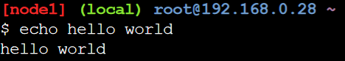

#When you application and it’s argument is fixed ENTRYPOINT ["echo", "Hello”] ENTRYPOINT ["World"] ENTRYPOINT ["World world"] >> This is the correct statement.

ENTRYPOINT ["echo"] CMD ["World"] This is industry best practice. Here application is fixed, and argument can be provided by end user. 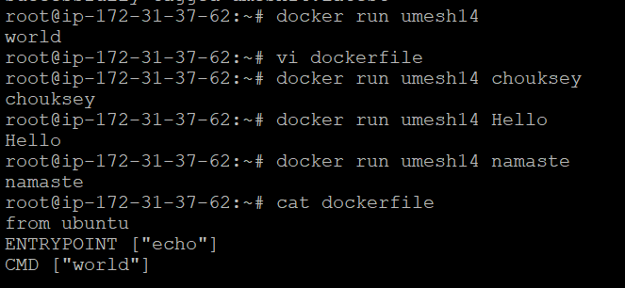

CMD ["echo"] CMD ["World"] CMD [“echo”, "World"] >> This is the correct statement.